Snapch-UTT

Project by Toussaint Baptiste, Martinez Lucas.

1. Introduction

The main objective of this project is to code an application which allows to create and manage student. Each student has personal characteristics: Name, Age, Years of study, Field of studies, City of residence, and Field of interest. The application allows student to follow each other according to their characteristic.

Our social network’s name is “Snapch’UTT”, and it has several features implemented:

* Snapch’UTT has a default implemented list of students.
* Create student and add it to the database.
* Change information about a student.
* Delete student from the database.
* Displays information about a specific student.
* Displays all student according to criteria: (age, field of studies…).
* Allow a specific student to follow others and displays his list of follower.
* Propose a list of followers for a student that matches with his information.

This report is divided in 5 part:

1. Description of the algorithm.
2. Project management: Organization, problem encounters and how resolve it.
3. How use Snapch’UTT?
4. Conclusion and perspective.
5. Appendix.
6. Description of the algorithm

We choose to create Snapch’UTT according to a specific architecture (1).

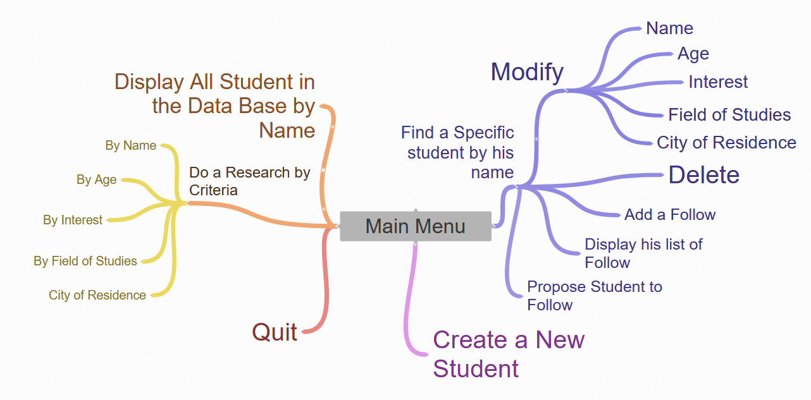

a. Features Tree